**Dairy Procurement System**



**BTech/III Year CSE/V Semester**

**15CSE302/Database Management Systems**

**Project Review -1**

|  |  |
| --- | --- |
| **Rollno** | **Name** |
| **CB.EN.U4CSE**18**043** | **Pavitra B** |
| **CB.EN.U4CSE**18**045** | **Preethi P** |
| **CB.EN.U4CSE**18**064** | **Vemireddy Asritha** |
| **CB.EN.U4CSE**18**071** | **Monisha S** |

**Amrita School of Engineering, Coimbatore**

## Department of Computer Science and Engineering

**2020 -2021 Odd Semester**

**Table of Contents**

## Title Page number

## Chapter 1 Introduction........................................................................................ 3

## Abstract......................................................................................................................6

## Chapter 2 Logical Database Design ER Diagram............................................7

**Entities.....................................................................................................................7**

**Attributes................................................................................................................7**

**Relationships.......................................................................................................... 8**

**ER diagram.......................................................................................................... 9**

## Chapter 3 ER to Relational Schema Mapping.................................................. 10

## Chapter 4 User Interface Screens........................................................................ 11

## References................................................................................................................15

# Chapter 1 Introduction

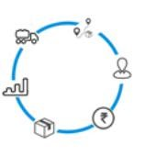Dairy production and consumption is an important part of our society. There are a lot of small scale milk producing farmers scattered around each area in villages and cities. Due to inadequate knowledge of proper channels to sell their production farmers suffer a loss. An integrated system connecting the farmers and the procurement centers either by government or private agencies can facilitate regular milk procurement from the farmers. The demand and supply chain can work efficiently with such a communication network.

Milk producers can register in this system. Procurement centers will collect milk from them. Regular payments will be done by the centers based on the quality of milk. Buyers can register and post their requirement quantity. The demand and supply will be matched by the procurement centers. The system connects all the stakeholders to ensure a successful business model.

Procurement are scheduled at a particular time in the morning and evening. Based on the quality and the number of liters poured by the farmer, his or her total amount is calculated. This process is done for each and every farmer who pours milk. Every farmer's milk is tested for its quality at the procurement centre. In order to get adequate quantities of quality (as per the rigorous Quality Assurance norms) milk, centers undertake a series of measures to help the farmers. Some of the measures taken are an advanced process of procuring and chilling the milk is done at the village/region level using ABC (Active Bulk Cooler) within 2 hours of milking.

There are primary and secondary routes for milk procurement. These routes have a regular route plan with the timing to pick up milk cans for each region/village in the morning and evening.The vehicle has to arrive at the milk chilling center at the fixed arrival times. A sample is taken for more detailed tests and pumped to the chilling unit. Once the tests are completed and the suitability of the entire chilling centers milk is confirmed to meet quality norms, the milk is loaded into a road milk tanker and sent to the dairy.

Each farmer's data (quantity, Fat & SNF% along with the farmer's unique number) is updated and transferred to the central database. Based on this data the farmer is paid every week/fortnight/10 Days once on a fixed day.

The following is a sample such network:

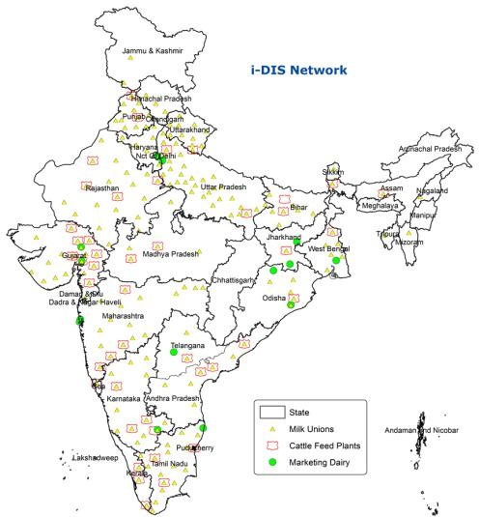

Data entry is done directly by the procurement centers. After posting raw data regularly, the system generates different types of pre-structured performance reports. The Analytical feedback from reports generated will enable the centers to review their performance and take corrective actions, if required. Based on the feedback, strategies will be prepared for increasing collection region/village wise and shared with Route Supervisors with a time bound target to improve milk collection. This also improves the chance to reach out to uncovered areas in the milk shed and at the same time increasing the intensity of milk collection from the existing collection areas.

The farmers can connect to the entire network from their home without having to commute and hunt for consumers. They can use their mobile phones to schedule procurement and payment on time. Even data entry is not a hassle for them. They also will get feedback on the quality of their milk, tips to improve the quality and an idea on the demand for quantity.

## Features of system:

1. Farmers having flexibility to pour their milk (3 Hours milk collection per shift)
2. Instant chilling at Village level within 2 hours
3. Farmers Milk Quality increased
4. Avoiding milk spoilage & spillage
5. Reduce aluminium can usage
6. Regular payment to farmers
7. Improved milk processing and storage capacity
8. Confirmed buyers of their dairy produce
9. Regular supply to dairy plants for dairy products
10. Strategic and policy decision support for Government and policy makers

Though many dairy procurement centers manage to connect to the farmers and large scale buyers, end consumers have different needs on the quality of milk. Farmers' knowledge on this is still inadequate. For example A1, A2 milk, etc,. The demand and price tags for each quality of milk is different. The current project will add these details into the system and provide information to the farmers regarding their demand.

# Sample activity of the system

1. Milk procurement area is identified.
2. Societies are created in each village. These societies are managed by villagers.
3. Milk producers/ Farmers become members of the societies.
4. Quality of milk is checked at the time of taking milk from the members. Members contribute milk in morning and evening time.
5. Optimized routes are designed by plants to collect milk from societies/procurement plants. Vehicles are sent to all societies to collect milk.
6. Milk is delivered to the dockyard of the dairy plant at both times or one time as per the policy of the plant. Again milk quality is checked at the dockyard.
7. Payment is made to farmers based on the quality of milk as per the policy of the plant (weekly/fortnightly/ 10 Days etc.)

# Abstract

Milk is one of the most in demand dairy product for humans but a highly perishable commodity. A platform is necessary to connect all the stakeholders in this network of producers and consumers. Data is keyed in by procurement centers by government or private agency while enabling cooperative milk procurement centers across the country to share key information such as number of village/region dairy cooperatives societies & their members, quantum of milk procured & sold, efficient route planning for procurement, supply to dairy plants where milk products are made & sold. Statistical reports on the data can be generated from the system to support policy makers, improve milk collection, reduce farmer’s loss and improve milk storage.

|  |  |
| --- | --- |
| **Chapter 2 Logical Database Design**  **Entities**   1. Bank_details 2. Employee 3. Admin 4. Farmers 5. Quantity_details_month 6. Society 7. Quality_assurance_employee 8. Route_supervisor 9. Payment_supervisor 10. Vehicles 11. Routes 12. Bills 13. Dairy_plants   **Attributes** | **ER Diagram** |
| * account_no * address_of_bank * IPSC_code * MICR_code * Name * mem_id * username * password | * address(street, area, city, state, pincode) * mobile_number * date_of_birth * qa_id * vehicle_id * routeno * rs_id |

* mem_id

|  |  |
| --- | --- |
| * billno * ps_id * society_name * society_no * tel_phone_no * no_of_employee * vehicle_no | * place1 * place2 * place3 * place4 * date * amount_of_milk * timing |

* amount

## Relationships

* quantity_per_person
* administrator
* workers
* allots
* pays
* routes_travel
* travels_to
* travels_from

# ER Diagram Chapter 3 ER to Relational Schema Mapping

Bank_details (account_no, address_of_bank, IFSC_code, MICR_code)

Employee(emp_id,name,street,area,city,state,pincode,mobile_number,joi n_date,department,date_of_birth,location)

Admin(username, password)

Farmers(mem_id,name,username,password,street,area,city,state,pincode, mobile_number,date_of_birth)

Inst_phone1=(emp_id,mobile_number)

Inst_phone2=(mem_id,mobile_number)

Quantity_details_month(date,time,quantity,mem_id)

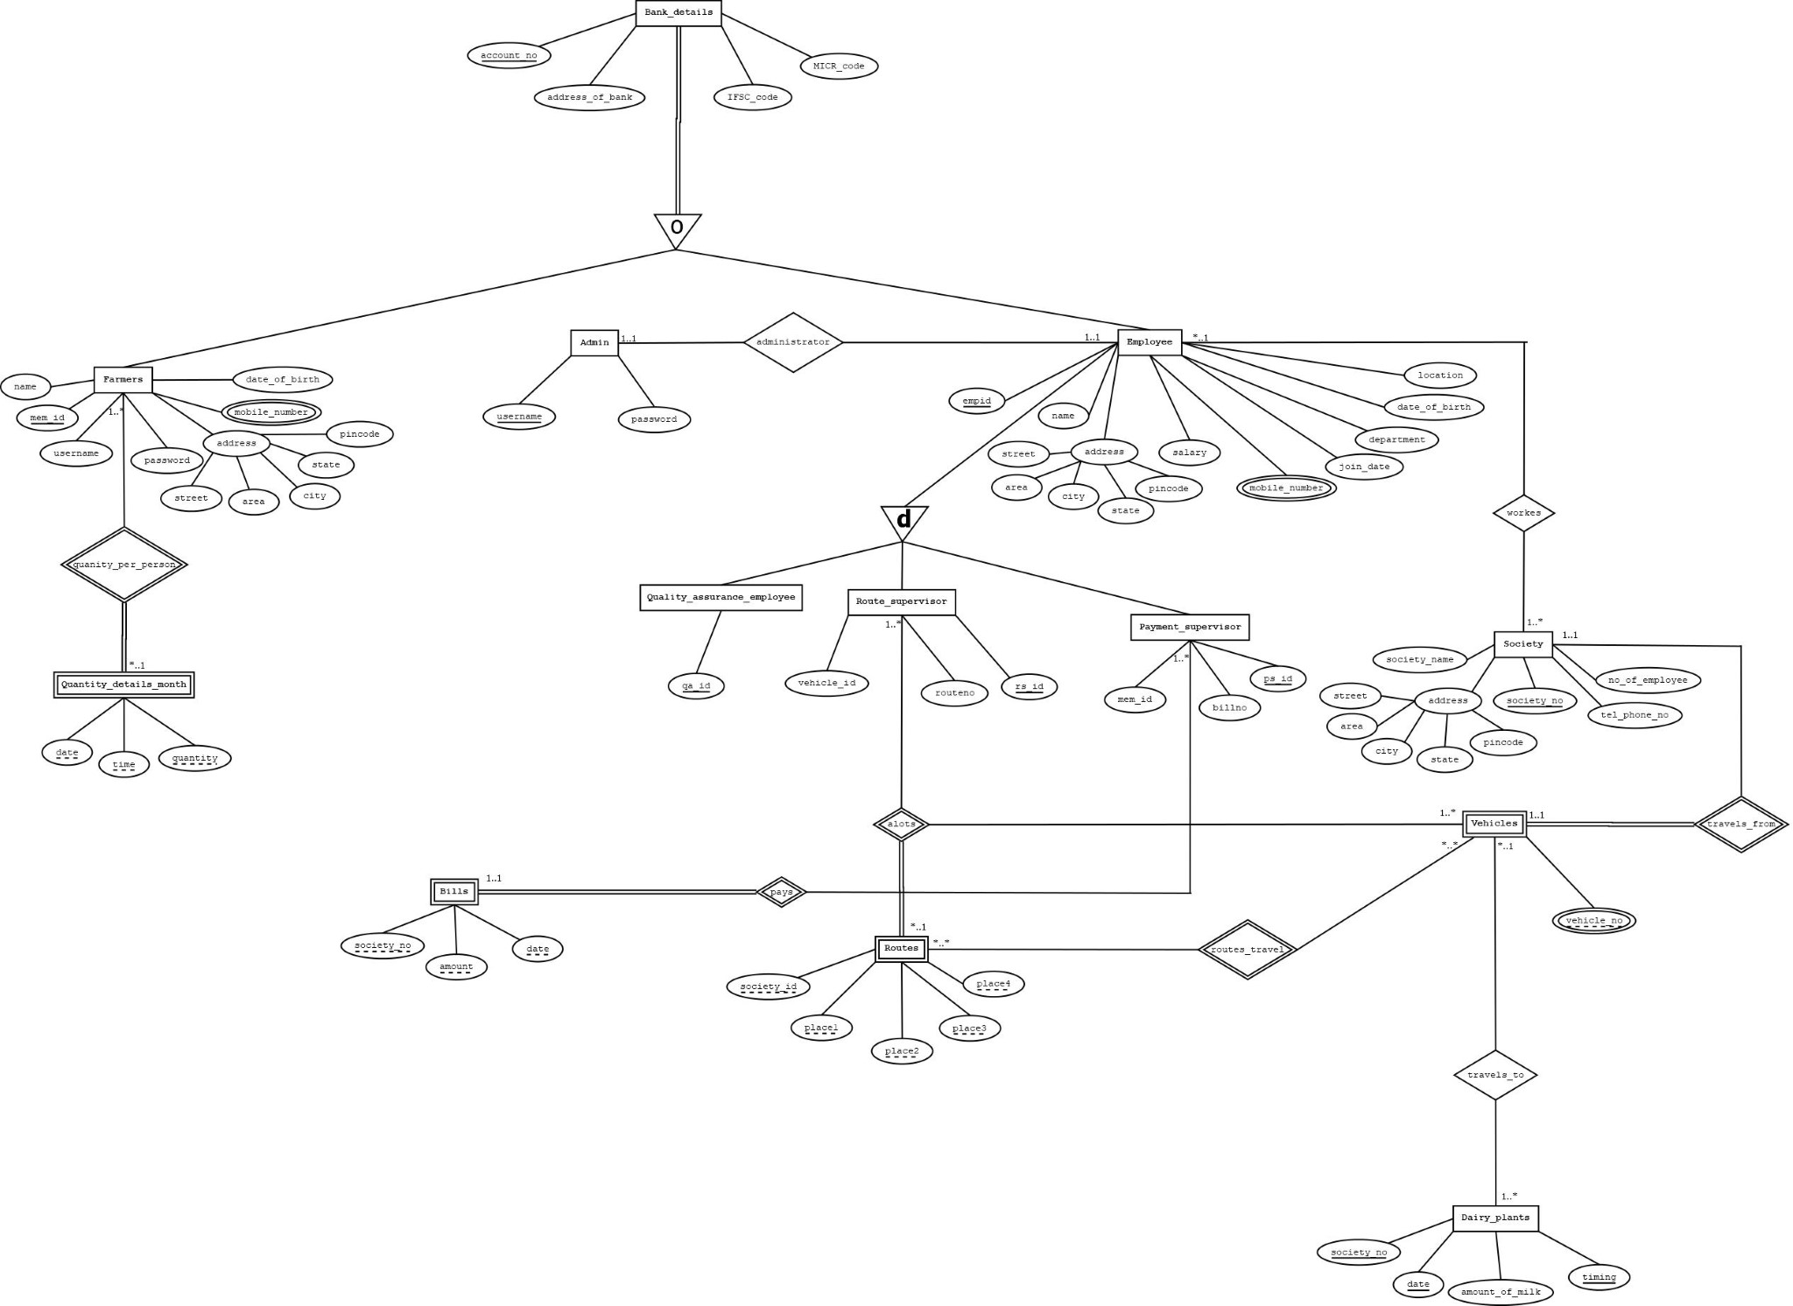Quality_assurance_employee(qa_id)

Route_supervisor(rs_id,vehicle_id,routeno)

Payment_supervisor(ps_id,mem_id,billno)

Vehicles(vehicle_no,society_no,vehicle_id,rs_id)

Society(society_no,society_name,address(street,area,city,state,pincode),tel_phonen o,no_of_employee)

Dairy_plants(society_no,date,amount_of_milk,timing)

Routes(society_no,place1,place2,place3,place4,rs_id,routeno)

Bills(society_no,amount,date,pa_id,billno,mem_id)

Administrator(username,emp_id)

Workers(emp_id,society_no)

# Chapter 4 User Interface Screens

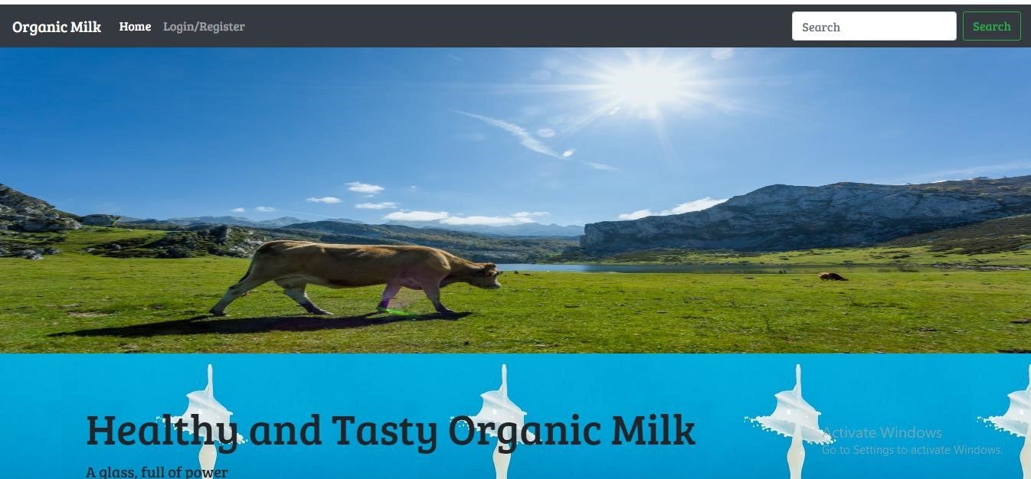

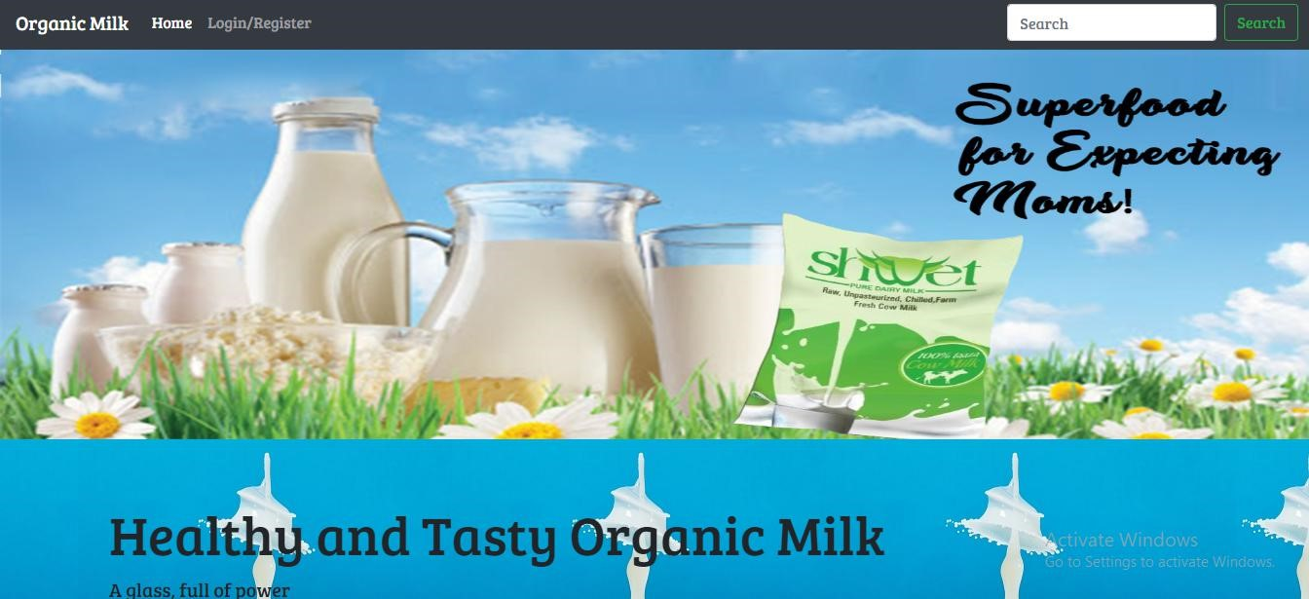

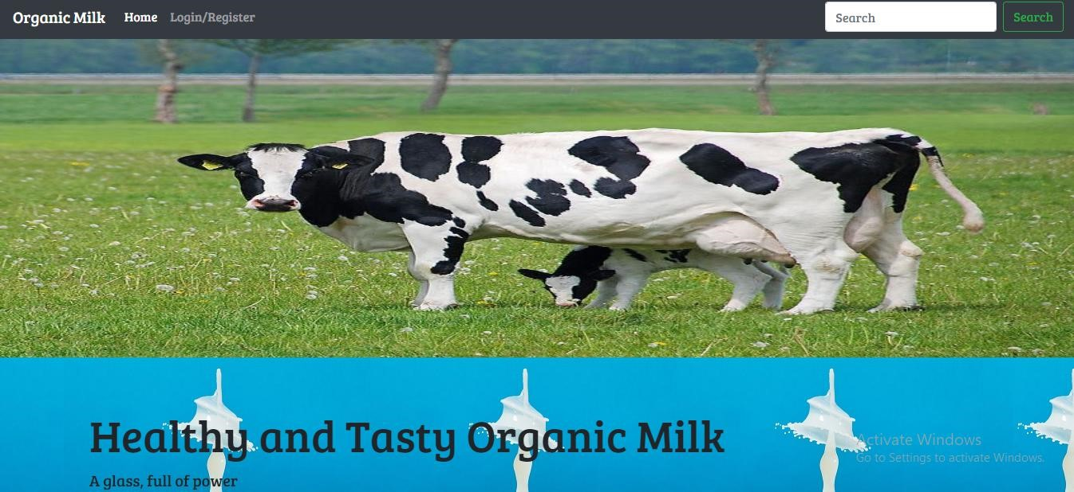

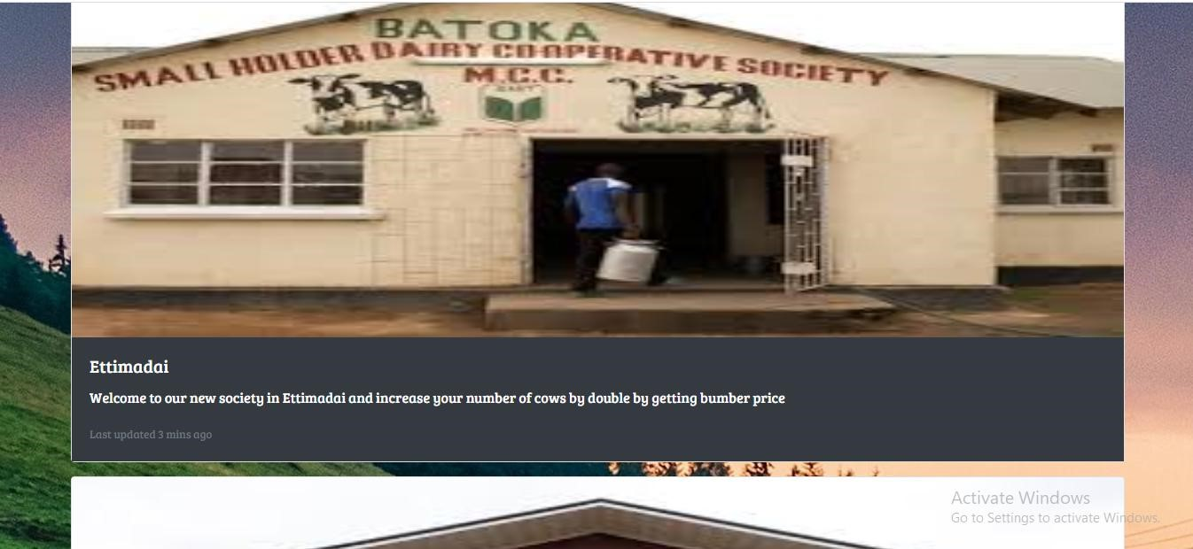

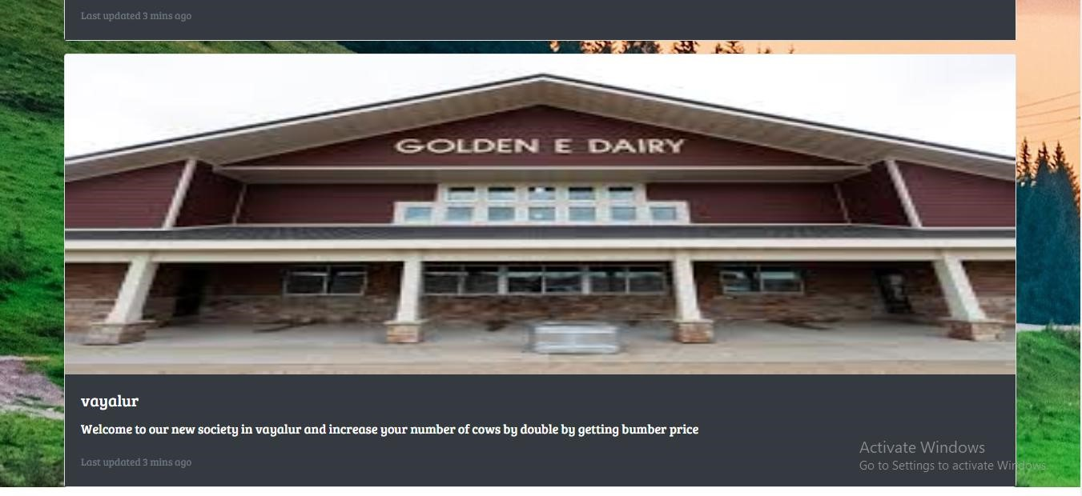

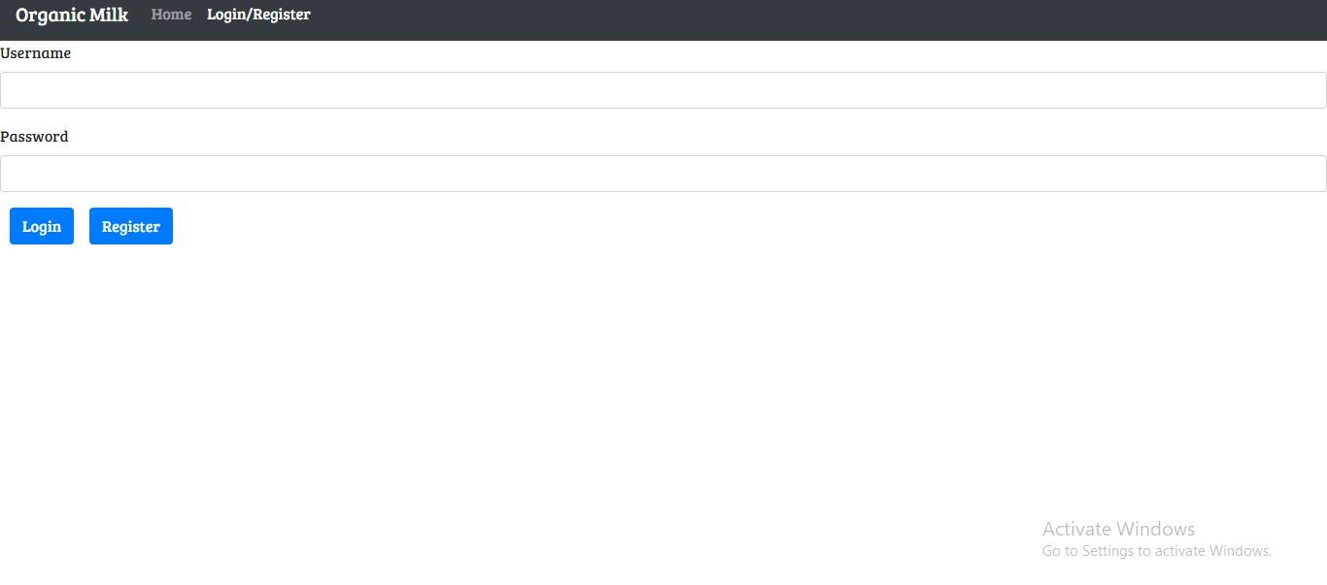

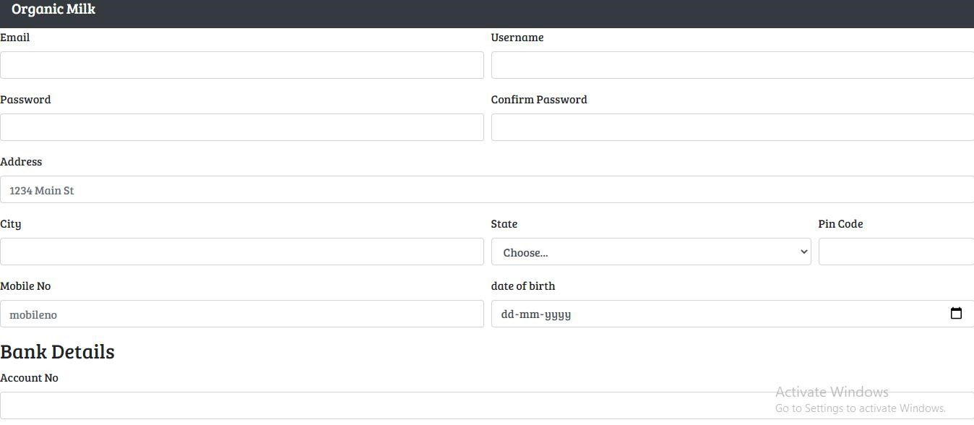

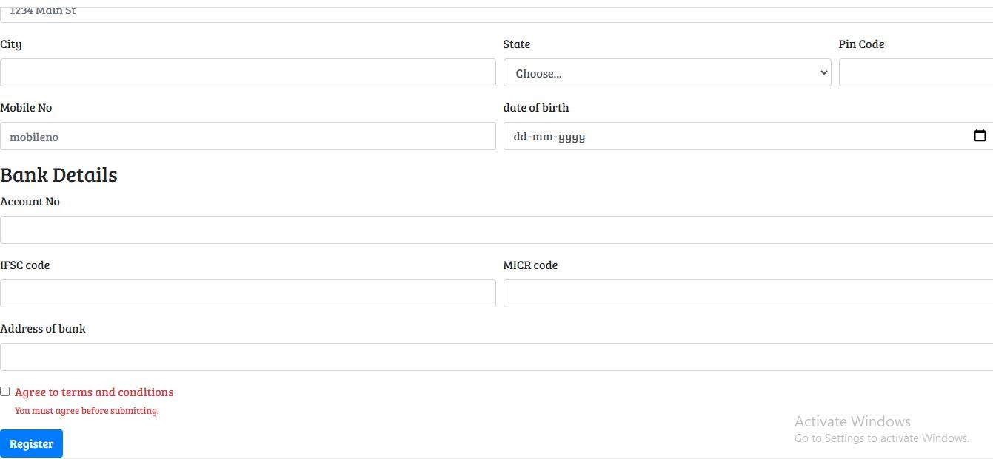

# References

1. Aavin Tamilnadu Co-operative Milk Producers’ Federation Limited(TCMPF). Accessed:23 August 2020 [Online]. Available: <https://aavinmilk.com/>
2. “Services”, National Dairy Development Board.Accessed: 4 September
   1. [Online]. Available: <https://www.nddb.coop/services/sectoral>
3. <https://www.mstcecommerce.com/eprochome/nddb/>
4. “i-DIS”, National Dairy Development Board.Accessed: 4 September 2020 [Online]. Available[:https://nddb.org/resources/idis](https://nddb.org/resources/idis)
5. “Infrstructure”,Hatsun Agro Product Limited. Accessed:23rd August
   1. [Online]. Available: <https://www.hap.in/milk-procurement.html>